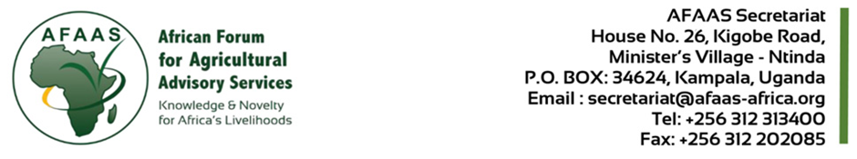
CALL FOR EOI FOR PROCUREMENT OF INDIVIDUAL CONSULTANT TO LEAD, FACILITATE AND CONDUCT THE MID-TERM REVIEW OF THE AGRA PROJECT
Contract No. AFAAS/AGRA/CQS/2026/0001
Date: 26th January, 2026

- Background:

The African Forum for Agricultural Advisory Services (AFAAS) is mandated by the African Union Commission to promote lesson learning, knowledge exchange, and innovation in Agricultural Extension and Advisory Services (AEAS) across Africa. The AFAAS plays a pivotal role as a convener and intermediary organization, linking research, policy, extension and practice. It is also mandated to strengthen AEAS and enhance agricultural productivity and drive inclusive, resilient, and sustainable food systems on the continent.

AFAAS received grant funding from AGRA project effective August 5, 2024 and ending January 31, 2027 a period of 30 months. For the implementation of the project activities, AFAAS will conduct procurements for goods, consulting and non-consulting services, in accordance with the AFAAS Procurement Management Manual.

The AFAAS in partnership with the Alliance for a Green Revolution in Africa (AGRA), is implementing a regional initiative titled “Scaling and Operationalization of Pluralistic Last-Mile Delivery, Extension and Advisory Services in Africa.” The project is being implemented in five AGRA-supported countries—Burkina Faso, Malawi, Nigeria, Rwanda, and Uganda—and seeks to modernize and decentralize Agricultural Extension and Advisory Services (AEAS) in order to increase productivity, market access, and resilience among smallholder farmers, particularly women and youth.
The project is now beyond the midpoint of its life-cycle, and therefore critical to undertake a structured Mid-Term Review (MTR) to systematically assess progress against planned objectives, identify operational and institutional bottlenecks, document emerging outcomes and innovations, and provide evidence-based recommendations to enhance delivery in the final third of the project.
Therefore, the AFAAS is desirous of engaging an independent consultant to lead and conduct an assessment on progress of project implementation, determine whether the project is on track to meet its defined goals and objectives, document innovations and good practices, identify constraints and bottlenecks to implementation, and generate evidence and insights to inform adjustments and refinements to implementation strategies, methodologies, and partnerships, without violating AGRA grant conditions.
the Mid-Term Review in order to ensure objectivity, impartiality, and credibility, while strengthening accountability, learning, and sustainability planning.
- Objectives of the Consultancy:

  - Overall Objective
To undertake a comprehensive review of technical, financial, institutional, and compliance performance of the AGRA-funded project implemented by AFAAS and its five Country Fora, with the aim of strengthening results delivery, learning, and sustainability.

  - Specific Objectives
The consultant will support AFAAS to:
- Assess technical progress against project outputs, indicators, and milestones, and how these contribute to the project objectives and goal.
- Evaluate efficiency in project delivery, and assess organizational compliance with AGRA’s and AFAAS fiduciary conditions.
- Assess the effectiveness of the delivery mechanisms of the project.
- Identify challenges and implementation bottlenecks, including risks at institutional, operational, and systemic levels.
- Generate forward-looking recommendations to enhance performance, partnerships, and sustainability in the final implementation phase.

- Duration of the Assignment
The assignment shall be implemented in a period of December 2025 - February, 2026, with the key milestones as detailed in the approved Terms of Reference.

- Consultant Qualifications and Experience
The following set of qualifications, experience and competencies will form the basis for selection of the individual consultant.
- A minimum of a Masters’ degree in Development Economics, Agricultural and Applied Economics, Statistics, Agricultural Extension, Development studies and any other relevant field
- A Post Graduate Diploma in Monitoring and Evaluation, or project Planning and Management will be an added advantage
- A minimum of five (5) years of demonstrated experience in conducting project evaluations of multi-country development project and donor driven development projects;
- Demonstrated understanding and experience in apply the OECD/DAC evaluation criteria in project
- Strong facilitation, analytical, and report-writing skills;

Interested individual consultants must provide information verifying that they are qualified to perform the assignment and meet the minimum required experience criteria above. The information to be submitted shall include: (i) Cover Letter for EOI; (ii) Technical and Financial Proposal detailing understanding of the assignment, approach and methodology, timeline (Workplan) and Proposed budget breakdown aligned with the deliverables (iii) CV in English; and (iv) References (Recommendation Letters) for work done. Expressions of interest must be delivered to the address below not later than 4th February, 2026, at 10.00 a.m. at the address below or electronically on email: secretariat@afaas-africa.org; or to address below:

The Consultant will be selected in accordance with the “Consultants Qualification Selection (CQS)” procurement method outlined in AFAAS Procurement Management Manual

Dr. Lillian Lihasi
Executive Director, AFAAS,
House No. 25; Kigobe Road; Minister’s Village
P.O BOX 34624 Kampala, Uganda
Telephone: +256-312313400.
Email: llihasi@afaas-africa.org;

Further information may be obtained from AFAAS procurement Unit: email: pwanzala@afaas-africa.org; or from the AEAS Lead; email: brosemirta@afaas-africa.org;

AFAAS Affirmative Action Statement on Employment: there is no discrimination based on gender race, religion, ethnic orientation, disability or health status.

