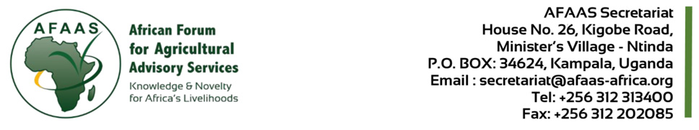
CALL FOR EOI FOR PROCUREMENT OF KNOWLEDGE MANAGEMENT SPECIALIST FOR AFAAS SECRETARIAT.
Contract Ref No. AFAAS/AUSO/GP-EASP/CQS/2025/0022
Activity: AGRA/GP-SAEP – KM, AUSO as per approved AWP&B2025
Item: Personnel Cost, AUSO - WP4 & 6 of the Approved PP2025
Date: 22nd December, 2025

- BACKGROUND
The African Forum for Agricultural Advisory Services (AFAAS) serves as the continental platform for mutual learning, collaboration, and innovation among Agricultural Extension and Advisory Services (AEAS) actors across Africa. Mandated by the African Union Commission, AFAAS plays a pivotal role in strengthening AEAS to enhance agricultural productivity and drive inclusive, resilient, and sustainable food systems on the continent.

AFAAS received grant funding from the European Commission (EC) towards the implementation of a project entitled “Global Programme for Small-scale Agroecology Producers and Sustainable Food Systems Transformation (GP-SAEP)’ funded by IFAD (Grant Number: 2000004649) effective 16th August 2023 with a project Closing Date set at 30th September 2026; AGRA project effective August 5, 2024 and ending January 31, 2027 a period of 30 months to carry out the project titled, “Scaling and operationalization of pluralistic last mile delivery, extension, and advisory services in Africa”; and from the European Research Executive Agency (REA) as delegated by the European Commission in support of the AUSO project (Project No. 101218840 — AUSO), effective 1st July 2025 and ending 30 June 2030 a period of 60 months. For the implementation of the project activities, AFAAS will conduct procurements for goods, consulting and non-consulting services, in accordance with the AFAAS Procurement Management Manual.

To fully capitalize on the knowledge generated across AFAAS programmes and to effectively deliver on project objectives, including the development of climate-relevant, inclusive knowledge products and tools that reach last-mile users; there is a clear need for a dedicated Knowledge Management Specialist to systematically curate, synthesize, package, and disseminate evidence in ways that inform practice, policy, and impact at scale. The consultant is expected to lead the compilation, synthesis and conversion of existing data and materials into knowledge products, success stories, and communication outputs, including videos, for dissemination through the AFAAS website, social media, other digital platforms, including partner platforms.
The consultant will also ensure that lessons, best practices, and innovations from AEAS networks and projects are systematically documented, packaged, and shared to influence policy, practice, and stakeholder engagement. In addition, the role shall play a critical part in strengthening AFAAS as a knowledge hub and enhancing visibility in the continent through collaboration with regional and Country Fora.

- OBJECTIVE OF CONSULTANCY
- The overall objective of the assignment is to strengthen information management & dissemination, knowledge sharing, and learning across AFAAS teams and all key stakeholders.
- To provide technical and coordination support in Knowledge Management and Communication (KM&C) aiming to enhance and promote the visibility of the AFAAS through the use of innovative KM&C methods and tools.

- DURATION OF ASSIGNMENT
The duration of the assignment is up to 7 months’ renewable based on performance review and workload analysis. The consultancy is expected to commence in 1st January, 2026 at a rate that may be agreed based on scope.
- QUALIFICATION AND EXPERIENCE
The following set of Qualifications, Experience and competencies will form the basis for selection of the consultant.
- A minimum of a master’s degree in Knowledge Management, Communications, Information Science, Rural Development, Agriculture, Information Technology, or a related field.
- A bachelor’s degree in Communications, Journalism, Agriculture Extension, Information Science, Knowledge Management, or a related field.
- At least 5–7 years of professional experience in knowledge management, communications or data management with experience in the agricultural or development sector in a regional, international, or donor-funded organization.
- Strong understanding of KM principles, practices, and tools.
- Strong data management and analytics capabilities.
- Proven experience in developing and implementing communication strategies, managing branding, and producing publications.
- Experience in organizing learning and knowledge-sharing.
- Strong understanding of digital communication platforms, data/content management systems, and web administration.

The individual consultant shall be selected based on the “Consultant Qualifications Selection (CQ) method” outlined in the AFAAS Procurement Management Manual. Interested individuals may obtain detailed information on the assignment at the address below from 08:00 – 17:00 (local time) latest December 29, 2025.

Interested individual consultants must provide information verifying that they are qualified to perform the assignment and meet the minimum required experience criteria above. The information to be submitted shall include: (i) Cover Letter for EOI; (ii) Technical and Financial Proposal (iii) CV in English; and (iv) References (Recommendation Letters). Expressions of interest must be delivered to the address below not later than 5th January, 2026 at 2.00 P.m. at the address below or electronically on email: secretariat@afaas-africa.org; or to address below:

Dr. Lillian Kidula Lihasi
Executive Director, AFAAS
Kigobe Road House No. 26 Ministers Village Ntinda
P.O BOX 34624 Kampala Uganda
Email: secretariat@afaas-africa.org; Tel: +256-312313400.

Copying the AFAAS Procurement Specialist, Grace Paddy Wanzala, email: pwanzala@afaas-africa.org;
Further information may be obtained from AFAAS procurement Unit: email: pwanzala@afaas-africa.org; or Executive Director; Email: llihasi@afaas-africa.org;

