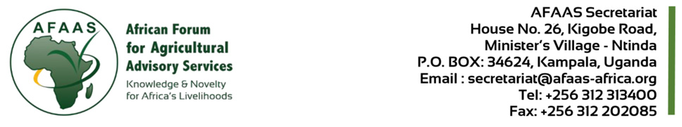
CALL FOR EOI FOR PROCUREMENT OF EXECUTIVE SUPPORT & PARTNERSHIP EXPERT FOR AFAAS SECRETARIAT
Contract No. AFAAS/AUSO/GF/CQS/2025/0023
Activity: AUSO WP6 and GF as per approved AWP&B2025
Item: AUSO and GF as per Approved PP2025
Date: 22nd December, 2025

- BACKGROUND
The African Forum for Agricultural Advisory Services (AFAAS) serves as the continental platform for mutual learning, collaboration, and innovation among Agricultural Extension and Advisory Services (AEAS) actors across Africa. Mandated by the African Union Commission, AFAAS plays a pivotal role in strengthening AEAS to enhance agricultural productivity and drive inclusive, resilient, and sustainable food systems on the continent.

The AFAAS received grant funding from the Gates Foundation towards the implementation of a project entitled “Nigeria public private partnership AI enabled Digital advisory planning” funded by Gates Foundation (Grant Agreement - Investment ID INV-069417) effective 15th September, 2025 with a project Closing Date set at March 31, 2026; and the second funding from the European Research Executive Agency (REA) delegated by the European Commission in support of the AUSO project (Project 101218840 — AUSO). REA has provided AFAAS with a grant for a period spreading from 1 July 2025 and ending 30 June 2030 spreading for a period of 60 months. For the implementation of the projects activities, AFAAS will conduct procurements for goods, consulting and non-consulting services, in accordance with the AFAAS Procurement Management Manual.

To enable AFAAS to effectively fulfil its continental mandate of coordinating, convening, and strengthening Agricultural Extension and Advisory Services in Africa, an Executive Support and Partnerships Officer shall provide structured executive support and proactive partnership management, ensuring that high-level engagements, strategic commitments, and partnerships are translated into timely, coherent, and impactful action.

The expert is expected to provide high-level support to the Executive Director by managing executive communications, coordinating strategic initiatives, and facilitating strategic partnerships and donor engagement. The role ensures the Executive Director’s office operates efficiently, while also advancing AFAAS’ external relations and resource mobilization.

- OBJECTIVE OF CONSULTANCY
The main objective is to provide high-level support to the Executive Director by managing executive communications, coordinating strategic initiatives, and facilitating strategic partnerships and donor engagement.
The specific objectives are:
- To provide strategic administrative, planning, and research support to the Executive Director or leadership team to ensure organizational efficiency.
- To identify, initiate, and manage multi-stakeholder partnerships (governments, NGOs, private sector) to leverage resources for AEAS projects.
- To ensure the Executive Director’s office operates in lockstep with the AFAAS strategy through rigorous planning and communication.
- To support the operationalization of Country Fora (CFs) and regional networks through expert advisory and training.
Resource Mobilisation:
- To develop a comprehensive resource mobilization strategy of AFAAS based on its objectives and priorities to systematically research and raise funds for AFAAS.
- To design and implement resource mobilization and strategic partnerships training programs to AFAAS staff and build their capacity in mobilizing resources and developing and maintaining partnerships at international and regional level.

- DURATION OF ASSIGNMENT
The duration of the assignment is up to 12 months’ renewable annually based on performance review and workload analysis. The consultancy is expected to commence in 1st January, 2026.

- QUALIFICATION AND EXPERIENCE
The Executive Support and Partnerships Expert will be required to possess the following qualifications and experience, not limited to providing:
- A minimum of a master’s degree in Business Administration (MBA), International Development, Public Policy, or related field.
- A bachelor’s degree in Business Administration, Public Administration, International Relations, Communications or related field,
- At least 5–7 years’ experience in executive support, partnerships management, donor relations/coordination, or resource mobilization within an NGO, international organization, or donor-funded environment.
- Proven experience in stakeholder engagement, event coordination, proposal development, and multi-stakeholder platforms.
- Proven experience in supporting senior/executive leaders, preferably in the agriculture sector.

The individual consultant shall be selected based on the “Consultant Qualifications Selection (CQ) method” outlined in the AFAAS Procurement Management Manual. Interested individuals may obtain detailed information on the assignment at the address below from 08:00 – 17:00 (local time) latest December 29, 2025.

Interested individual consultants must provide information verifying that they are qualified to perform the assignment and meet the minimum required experience criteria above. The information to be submitted shall include: (i) Cover Letter for EOI; (ii) Technical and Financial Proposal (iii) CV in English; and (iv) References (Recommendation Letters). Expressions of interest must be delivered to the address below not later than 5th January, 2026 at 10.00 a.m. at the address below or electronically on email: secretariat@afaas-africa.org; or to address below:

Dr. Lillian Kidula Lihasi
Executive Director, AFAAS
Kigobe Road House No. 26 Ministers Village Ntinda
P.O BOX 34624 Kampala Uganda
Email: secretariat@afaas-africa.org; Tel: +256-312313400.

Copying the AFAAS Procurement Specialist, Grace Paddy Wanzala, email: pwanzala@afaas-africa.org;
Further information may be obtained from AFAAS procurement Unit: email: pwanzala@afaas-africa.org; or Executive Director; Email: llihasi@afaas-africa.org;

